
FRONTBRIDGE SECURE EMAIL
FrontBridge Secure Email is a convenient, easy-to-use email encryption service that safely delivers your confidential business communications.  Experts estimate that 75% of the total knowledge exchange occurring via email contains proprietary, intellectual property, and must be protected as a valuable corporate asset. But the need for increased confidentiality is only one of the many reasons corporations must add protection to existing email communications. Government and industry regulations, such as those posed by HIPAA and Gramm-Leach-Bliley, offer even more compelling reasons for corporations to secure messages to meet legal compliance.  However, existing solutions – such as server-to-server level encryption, public key infrastructure (PKI), and password-protected files – are not only ineffective, but expensive and complicated to integrate and to deploy. These solutions do not provide the flexibility, sophistication and ease-of-use that corporate users need to deploy email encryption throughout their enterprise.  Secure Email enables users to send and receive encrypted email directly from their desktops as easily as regular email, to anyone at any time. With a single click, users can encrypt and deliver any business communication without complex hardware and software to purchase, configure and maintain. Leveraging multiple types and layers of encryption, our highly scalable solution meets industry standard protocols, and has been validated by industry and government experts.  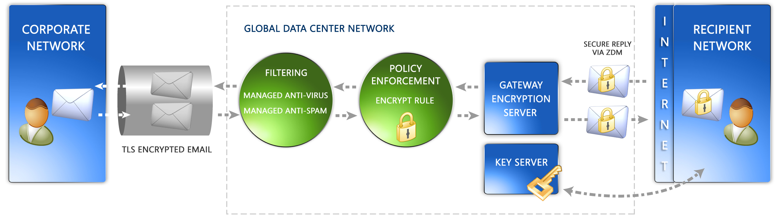  HOW IT WORKS  In traditional encryption systems such as PKI, certificates bind public keys to identities. Users must pre-enroll in server systems to receive a certificate, which is signed by a Certification Authority, so that they can send and receive secure messages.  Secure Email incorporates Identity-Based Encryption (IBE) technology in a managed service platform. IBE – developed by Voltage Security, FrontBridge’s technology partner – is a breakthrough in security and usability for message encryption. Using the recipient’s email address as the public key, IBE automatically binds the user’s identity to the public key, thus eliminating the need for certificates.  continued…
  FREE TRIAL
  Sign up today!
  www.frontbridge.com/trial
  BENEFITS
  • Send encrypted emails to anyone, regardless of their system configuration.
  • Decrypt and read emails securely, without installing client software.
  • Strong, automated encryption with a cost-effective infrastructure.
  • Protect sensitive information and data leaving your email gateway, consistently and automatically.
  • Comply with security and privacy requirements such as HIPAA and Gramm-Leach-Bliley.
  • No hassling with key and certificate management, or searching for easy and secure ways to obtain long strings of alphanumeric digits from the people with whom you need to communicate.
  • Generate keys on the fly.
  • Eliminate the need for capital investment, and offload maintenance and upgrades to FrontBridge, the messaging experts.
FRONTBRIDGE SECURE EMAIL
Transparent Encryption
When the user sends an email, it travels to the FrontBridge Global Network via a TLS-encrypted tunnel, and is automatically encrypted at the gateway according to rules created and managed within the FrontBridge Policy Enforcement module.
When a message is encrypted, a private key for the recipient is created and stored securely on our network. The private key is made available to the message recipient when they decrypt their message. The recipient does not have to pre-enroll to receive and decrypt the message. In fact, the recipient may have never received a prior email from the sender.
Unlike traditional encryption services, our encryption process is entirely transparent to the sender, who does not need to do anything other than write and send the email as usual.
Secure, Web-based Decryption
Upon receiving a Secure Email encrypted message, the recipient completes an easy two-step authentication process via email answerback to verify the recipient’s identity.
Upon completion of this process, the recipient decrypts and views their message using the Zero Download Messenger (ZDM). The ZDM is a clientless, browser-based method that allows recipients to decrypt and read their secure message and its attachments. The ZDM even allows the recipient to reply securely, with no software installation or setup required. Further, the encrypted message remains in the recipient’s email inbox for access at any time.

FEATURES
• Policy-based Encryption encrypts messages at the gateway based on policy rules for compliance and business requirements.
• IBE Encryption Technology uses a common ID for public key.
• Encrypted email delivered directly to recipients’ inbox and not to a Web service.
• Zero Download Manager (ZDM) enables secure, Web-based decryption and encrypted replies for any recipient of Secure Email.
• Managed key server eliminates the need for certificate maintenance.
• Communication via TLS-enabled network further ensures messages stay secure.
The information contained in this document represents the current view of Microsoft Corporation on the issues discussed as of the date of publication. This document is for informational purposes only. MICROSOFT MAKES NO WARRANTIES, EXPRESS OR IMPLIED, IN THIS DOCUMENT. © 2005 Microsoft Corporation. All rights reserved.

