
FRONTBRIDGE POLICY ENFORCEMENT
FrontBridge Policy Enforcement is a managed messaging service that ensures inbound and outbound corporate messaging complies with company policies and other regulations.  Email plays a critical role in the daily operations of business. As email has become the dominant business communication tool, many rules and regulations have been created to govern email content and usage.  Governmental regulations add a layer of complexity to managing corporate email. Specific laws govern email communications in several industries including financial services and healthcare. The Gramm-Leach-Bliley Act, SEC Rule 17a, NASD Rules 3010 and 3110, and the Health Insurance Portability and Accountability Act (HIPAA) all contain provisions for maintaining security, privacy and non-disclosure in email communications.  Even without governmental compliance drivers, policy enforcement of inbound and outbound communication makes good business sense. Accepting the fact that email has become a common vehicle used to communicate time-sensitive and confidential business information, email should be protected as a critical corporate asset. Effective policy management and enforcement will help secure that asset.  FrontBridge Policy Enforcement simplifies the task businesses face when implementing uniform policy rules to regulate message content and delivery. This frees up resources within the network and messaging infrastructure while ensuring compliance with corporate and regulatory message policies.  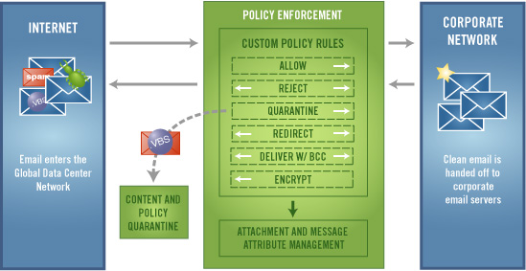  HOW IT WORKS  Functioning as a pre-emptive message filtering service, FrontBridge Policy Enforcement works as a message processing layer between the Internet and corporate networks. Both inbound and outbound email enters the FrontBridge Global Network where FrontBridge filters messages according to the customer-defined rule set.  continued…
  FREE TRIAL
  Sign up today!
  www.frontbridge.com/trial
  BENEFITS
  • Easily and uniformly implement policy rules to regulate message content and delivery.
  • Ensure compliance with corporate messaging policies.
  • Improve use of network and messaging infrastructure.
  • Monitor message traffic and usage with BCC action.
  • Manage message traffic flow with Redirect action.
  • Review messages before delivery to corporate network with Quarantine action.
  • Measure rule impact before implementation with test rules.
  • Enforce message size limits for email entering and leaving the SMTP gateway.
  • Use message policies to reduce corporate liability and protect intellectual property via the distribution of inappropriate information.
  • Helps companies comply with laws and regulations such as SEC Rule 17a, NASD Rules 3010 and 3110, Health Insurance Portability and Accountability Act (HIPAA) and Gramm-Leach-Bliley Act.
FRONTBRIDGE POLICY ENFORCEMENT
Policy Definition and Enforcement
FrontBridge Policy Enforcement makes it easy to build policy rules that filter the message flow. Using an intuitive web interface, security administrators can construct custom rules to uniformly filter messages. FrontBridge Policy Enforcement allows messages to be filtered by attributes including message size, attachment types, subject content, message content, originating domain, sender and recipient.
Message Handling
Should a message get flagged by a rule, FrontBridge Policy Enforcement offers several options for processing the message. The message can be blocked, quarantined, redirected to another recipient or delivered to the original addressee with a Blind Carbon Copy (BCC) to a designated recipient. Additionally, FrontBridge Policy Enforcement includes Allow rules, which assure delivery for messages that match rule criteria.
FEATURES
• Web-based administration for rule writing and editing.
• Policies can be created to block messages based on:
• Words and phrases in the subject and body
• Message size
• Attachment types
• Number of recipients
• Sender and Recipient addresses
• IP address or Domain name
• Comments in policy rule writer allows annotation of rule set.
• Methods to handle messages flagged by policy rules include:
• Allow message
• Block message
• Quarantine message for review
• Redirect message to an alternate recipient or mailbox
• Deliver message with BCC
• Encrypt message (requires FrontBridge Secure Email Gateway)
• Rule expiration allows administer to specify date for rule cessation.
The information contained in this document represents the current view of Microsoft Corporation on the issues discussed as of the date of publication. This document is for informational purposes only. MICROSOFT MAKES NO WARRANTIES, EXPRESS OR IMPLIED, IN THIS DOCUMENT. © 2005 Microsoft Corporation. All rights reserved.

