
FRONTBRIDGE MESSAGE ARCHIVE
FrontBridge Message Archive is an advanced message archiving and compliance system for email and instant messages (IM).  Regulations such as SEC Rule 17a-4, NASD 3010, Sarbanes-Oxley, and HIPAA impose a variety of message retention and supervisory requirements on businesses. Those regulations plus the potential burden of legal discovery require enterprises to take a proactive approach to email and IM retention policies to mitigate risk and meet regulatory compliance standards.  Part of the FrontBridge Message Compliance Services, Message Archive helps businesses preserve the productivity and benefits of electronic communication in the enterprise while complying with the regulatory and legal demands placed upon businesses and their communication systems.  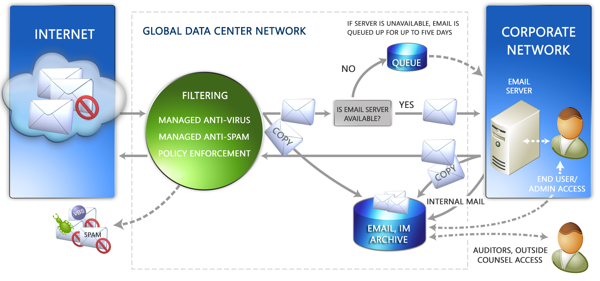  HOW IT WORKS  Message Archive intercepts and makes copies of inbound, outbound, and internal email as well as IM and other communications such as Bloomberg mail and stores those message copies in a secure, tamperproof archive. Comprehensive message indexing allows stored messages to be searched by header, subject line, and body contents, including attachments.  Stored messages are accessed through a single, unified interface. The Web-based interface provides tools for searching and recovering messages as well as compliance workflow tools for supervising and monitoring electronic communications.  The Web-based interface also includes tools for composing, reading, and replying to email, ensuring continual access to all email functionality even when the primary email environment is unavailable or a backup email system is needed.  As a business continuity tool, the archive can be accessed 24/7 by email administrators and end users to recover messages that may have been lost or deleted from the primary email environment. If a business’ primary mail environment is down, Message Archive continues to copy messages to the archive and queues the original message for delivery once the primary email environment is restored.  continued…
  BENEFITS
  • Interception-based archiving captures messages in transit and works in concert with FrontBridge Message Security Services to ensure spam, viruses, and other unwanted content are kept out of the archive.
  • Service delivery eliminates the need for capital investment, offloads maintenance and upgrades to FrontBridge, the messaging experts.
  • Easy-to-use Web-based interface requires minimal training, allows access to the message store and compliance tools for administrators, supervisors, and end users from any location.
  • End users can have access to their personal message store with no intervention needed by help desk personnel or administrators.
  • Easily comply with SEC and NASD message monitoring requirements, demonstrate compliance with evidentiary reports
  • Always-on email continuity and disaster recovery capability, plus continuous access to email and all email functionality.
FRONTBRIDGE MESSAGE ARCHIVE
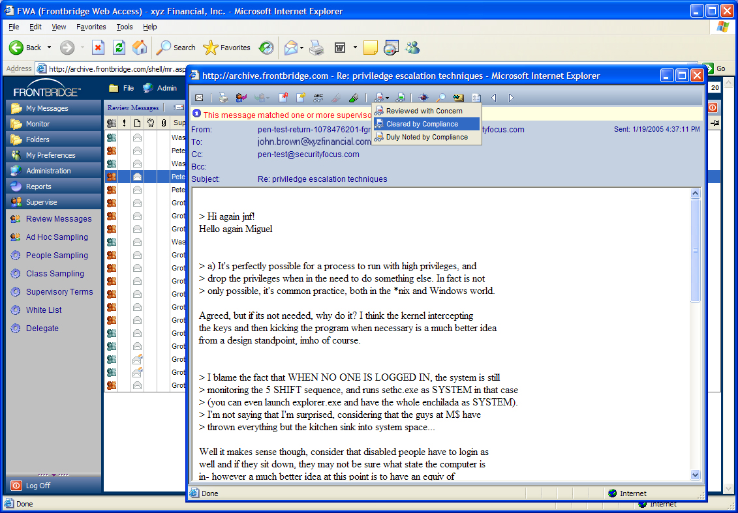  Integrated compliance workflow tools make quick work of required activities such as message sampling and message review.  FEATURES  • Email and IM storage with integrated compliance tools  • Interception-based archiving for inbound and outbound email and IM; internal email captured via journaling from the primary email server  • Web-based access to message archive and integrated compliance tools for end users, administrators, and supervisors  • Compliance workflow tools for supervising and monitoring messages; intelligent tools for keyword and random message sampling  • Attorney/client message tagging to protect confidential information  • Event log and audit trail to track and report system activity  • Web-based tools for composing, reading, forwarding, restoring, and replying to email  • Message restoration after outage  • Searchable message store; search message header, subject, body, and attachments; tag, retrieve and restore searched messages  • Summary and drill down email traffic reports and SEC and NASD evidentiary reports; reports can be scheduled and delivered via email
  TECHNICAL SPECS
  • Message Archive Web Access requires Internet Explorer 6 or later version.
  • Message storage via Oracle database and EMC hardware
  • IM platforms supported: Omnipod, Akonix, IM Logic, FaceTime, Parlano
The information contained in this document represents the current view of Microsoft Corporation on the issues discussed as of the date of publication. This document is for informational purposes only. MICROSOFT MAKES NO WARRANTIES, EXPRESS OR IMPLIED, IN THIS DOCUMENT. © 2005 Microsoft Corporation. All rights reserved.

