
FRONTBRIDGE DIRECTORY SERVICES
FrontBridge Directory Services is a multi-functional service that improves message handling and routing for inbound message traffic through user grouping, intelligent email routing, and selective message receipt.  The continued growth of email usage – from both legitimate and illegitimate senders – puts extra strain on email servers and network infrastructure. For example, email dictionary attacks from spammers result in thousands of inbound messages addressed to non-existent users, which burden networks and servers with unneeded messages to process. In another example, enterprises with remote locations and disparate email servers must route mail to remote users, adding complexity to email delivery.  Directory Services reduces that strain by allowing organizations to specify users for whom to accept email and define delivery groups for intelligent routing and group policies, thereby improving the efficiency of a company’s messaging infrastructure.  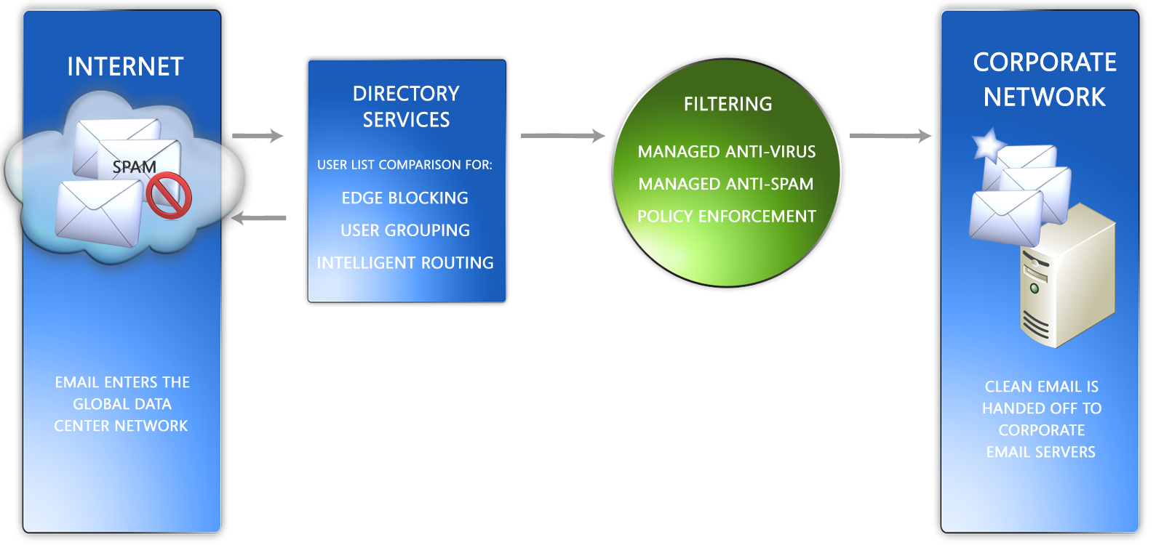  HOW IT WORKS  Acting as a pre-emptive filter for inbound email, FrontBridge Directory Services provides a range of functionality for more intelligent handling of inbound messages.  Message Reject  Messages for non-existent users is a burden that can be eliminated by uploading lists of valid email addresses via the FrontBridge Admin Center or by Secure FTP. After a user list is uploaded, incoming email addressed to users not on the list is returned to the sender with a 550 error message, whereas users included in the list receive their email as usual. Without Directory Services, FrontBridge processes all inbound email, including messages for non-existent users.  Some organizations may want to review rather than reject email addressed to users not included in their user list. FrontBridge Directory Services includes a reject test mode where email for non-existent users is redirected to a specified mailbox. Reject test mode also allows an organization to test their uploaded user list.
  BENEFITS
  • Improves use of network and messaging infrastructure by eliminating unwanted messages before they reach the corporate network.
  • Reduces inbound message traffic by rejecting unwanted email.
  • Eliminates Dictionary Attacks on a company’s messaging system.
  • Allows email policy rules specific to work groups and team to be implemented and managed.
  • Routes messages directly to the appropriate email server.
FRONTBRIDGE DIRECTORY SERVICES
Pass-Through
FrontBridge Directory Services includes a Pass-Through feature where messages addressed to users not included in the uploaded user list bypass all filtering services and are delivered directly to the company’s email server. All messages for recipients included in the user list are processed and filtered according to the domain’s settings.
Grouping for Filtering
FrontBridge Directory Services allows companies to configure policy rules for select groups of users within a domain. Each user included in the user list upload is associated with a group name. From within the Admin Center, a virtual domain is created and configured for each group name specified in the user list. For example, virtual domains could be set up for the Human Resources and IT groups where email is filtered and processed according to the policies set up for those groups.
Intelligent Routing
With Intelligent Routing enabled, FrontBridge Directory Services can deliver email to recipients at a specific location. For example, recipients of email within the same company but in different geographic locations can have their email routed to a local email server. Intelligent Routing requires each user to be associated with a group and each group associated with a virtual domain. Using the Admin Center, each virtual domain can be configured to redirect email to specific servers within the organization.

FEATURES
• Message Reject – Messages sent to non-existent users within a domain are rejected and returned to the sender.
• Reject Test – Messages sent to a recipient not included within a user list are redirected to a specific email address for review.
• Pass-Through – Messages sent to a recipient not included within a user list bypass filtering services and are delivered directly to the company email server.
• Grouping for Filtering – Allows companies to configure policies for groups of users within the same domain. A NO GROUP setting allows group processing where the default domain settings apply.
• Intelligent Routing – Redirects email addressed to a single domain to specific locations within the company.
• Intuitive web interface allows easy configuration of filtering and routing messages.
• Email policy rules can be applied to groups.
• Allows trial testing of filtering policies with a subset of the user population.
• Multiple options for handling unwanted email.

The information contained in this document represents the current view of Microsoft Corporation on the issues discussed as of the date of publication. This document is for informational purposes only. MICROSOFT MAKES NO WARRANTIES, EXPRESS OR IMPLIED, IN THIS DOCUMENT. © 2005 Microsoft Corporation. All rights reserved.

