
FRONTBRIDGE ANTI-VIRUS
FrontBridge Anti-Virus is a managed service that protects businesses from receiving email-borne viruses and other malicious code.  The widespread acceptance of email as an efficient means of business communication has left corporate networks vulnerable to fast-moving viruses attached to messages as a dangerous payload. Email-borne viruses replicate at lightning speed and can overwhelm even the best equipped IT departments that are tasked with keeping viruses at bay.  FrontBridge Anti-Virus significantly reduces the IT burden by capturing viruses before they enter the corporate network. Using multiple strategies to protect against this malicious code, FrontBridge is the front line of defense to keep enterprises virus free and assure a clean message stream. In addition to guarding against viruses harbored by inbound email, FrontBridge also protects businesses in their outbound email communications. A company’s reputation is critical, and being the source of a damaging virus that infects the systems of customers, partners and suppliers can do irreparable harm to that reputation.  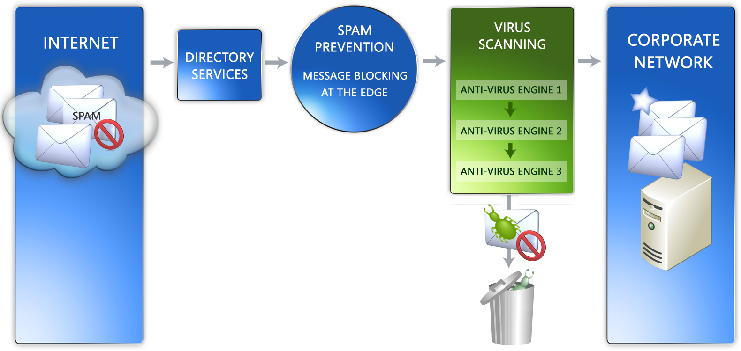  HOW IT WORKS  Functioning as a pre-emptive anti-virus security service, Anti-Virus works between the Internet and the Corporate Network preventing viruses and malicious code from reaching corporate email servers. Before a message reaches its final destination, it enters the FrontBridge Global Data Center Network where FrontBridge processes the message using a multi-pronged strategy to protect against viruses.  Multiple Anti-Virus Engines  At the core of FrontBridge’s virus fighting strategy are multiple, commercial-grade anti-virus engines, integrated at the API level. At all times, FrontBridge uses at least two different anti-virus engines with the ability to immediately engage additional engines when acute threats warrant additional coverage. Leveraging its partnerships with leading anti-virus vendors such as Kaspersky, Sophos and Symantec, FrontBridge provides timely and critical updates with virus definitions updated every 10 minutes, 24/7. FrontBridge’s anti-virus partnerships provide updates to the FrontBridge network before new virus antidotes are available to the general public.  continued…
  FREE TRIAL
  Sign up today!
  www.frontbridge.com/trial
  BENEFITS
  • “Set it and forget it” offloads management and maintenance of email protection; no anti-virus engines to update.
  • Prevents viruses from reaching the corporate network via email.
  • Multiple anti-virus engines ensure complete, up-to-date coverage against known viruses and the broadest coverage available; engines integrated at the API level for early and quick updates from vendors.
  • FrontBridge technology partnerships with anti-virus vendors ensure rapid anti-virus definition updates, often before definitions are publicly available.
  • Reduces virus risk without affecting productivity; grouping allows an organization to eliminate risk for 98% of its users.
  • Multi-pronged strategy at a significantly lower cost than most companies would pay to purchase, deploy and manage their own multi-engine solution.
FRONTBRIDGE ANTI-VIRUS
Additional measures
FrontBridge delivers additional protection from viruses via Spam Prevention technology as well as the use of Policy Enforcement and Directory Services. Increasingly, spam carries a virus payload. FrontBridge’s spam prevention techniques – which block spam before it enters the network – shrink this double-barrel threat. And by using Directory Services to define email delivery groups, FrontBridge customers can implement policy rules to limit the recipients of executable content, such as .EXE files, reducing the opportunity for malware to enter corporate networks.
Outbound Virus and Content Scanning
In addition to scanning inbound email, FrontBridge protects outbound communications from propagating viruses and deviant code. FrontBridge intercepts outbound messages, scanning and cleaning messages before they are delivered to intended recipients, to ensure all outbound email is reliable, secure and of the utmost integrity.

FEATURES
• Multiple commercial-grade anti-virus engines integrated at the API level.
• Virus definition updates every 10 minutes, 24/7.
• Policy-based grouping for limiting recipients of executable content.
• Spam prevention technology for blocking unwanted email that may contain malware payload.

The information contained in this document represents the current view of Microsoft Corporation on the issues discussed as of the date of publication. This document is for informational purposes only. MICROSOFT MAKES NO WARRANTIES, EXPRESS OR IMPLIED, IN THIS DOCUMENT. © 2005 Microsoft Corporation. All rights reserved.

