
FRONTBRIDGE ANTI-SPAM
FrontBridge Anti-Spam is a managed service that deploys multiple layers of technology to protect businesses from receiving unsolicited email.  Left unchecked, the scourge of spam can overwhelm businesses, destroying the productivity and benefits of this vital business communication tool. The sheer volume coupled with spammer creativity leaves businesses with no option but to turn to technology to combat this ever-present threat.  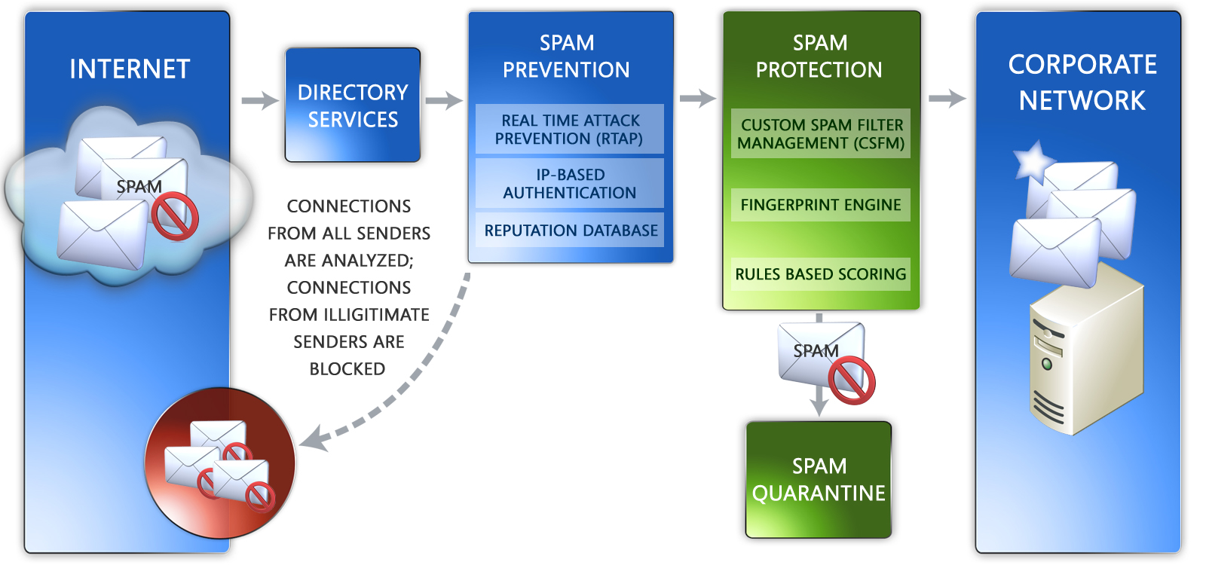  HOW IT WORKS  FrontBridge Anti-Spam provides preventative and protective spam defense, keeping spam from reaching corporate email servers. A simple re-direct of a business’ MX record routes all of an organization’s messages to a data center in the FrontBridge Global Network, where FrontBridge processes messages using a multi-layered approach.  Spam Prevention  At the edge of the FrontBridge network, FrontBridge deploys several pieces of technology to prevent spam from entering the network. RTAP, FrontBridge’s unique and proprietary email traffic analysis technology, quickly detects, in real-time, anomalies in email traffic in order to block incoming connections from spammers. In addition, FrontBridge uses IP-based authentication, including SPF lookups, to ensure email is coming from a known sender as well as who it claims to be from. Finally, FrontBridge employs its own reputation database with lists of the most flagrant spammers to prevent unwanted message delivery.  Spam Protection  FrontBridge uses several methods of message analysis to protect corporate networks from spam, including Fingerprinting, Rules-Based Scoring, and Custom Spam Filter Management (CSFM).  FrontBridge’s fingerprinting technology takes a “digital picture” of each message and matches it against known profiles of spam messages to detect unwanted email and flag it as spam. In addition, messages are scored against FrontBridge’s proprietary database of spam rules, assigning scores to messages based on more than 20,000 unique characteristics of spam and  continued…
  FREE TRIAL
  Sign up today!
  www.frontbridge.com/trial
  BENEFITS
  • FrontBridge deploys multiple layers of technology to prevent and protect against unwanted email traffic from reaching corporate networks.
  • With no user tuning, FrontBridge blocks more than 95 percent of unwanted email, reducing message traffic and improving the efficiency of messaging infrastructure.
  • FrontBridge delivers the lowest false positive rate of any vendor (1 in 250,000) ensuring delivery of all business email; in addition, FrontBridge has the lowest false critical rate (false positive for mission critical message) of any vendor (1 in 1,000,000).
  • “Set it and forget it” philosophy offloads management and maintenance of email protection; No white lists to upload or maintain.
  • The FrontBridge team of spam analysts have broad exposure to millions of messages daily; the team constantly updates spam rules, reputation database, and fingerprint to stay ahead of spammers’ ever-changing tactics.
  • Service delivery eliminates the need for capital investment and offloads all maintenance and upgrades to FrontBridge, the messaging experts.
  • Fully scalable solution matches the size of any enterprise.
FRONTBRIDGE ANTI-SPAM
legitimate email. When a message’s score reaches a defined threshold, it is flagged as spam. For additional message scrutiny, FrontBridge customers can enable Custom Spam Filter Management (CSFM), providing an additional layer of protection from messages with defined characteristics such as Web bugs and embedded HTML and JavaScript tags.
Spam Handling
Once detected, multiple options are offered for spam handling, including holding spam in the offsite FrontBridge Spam Quarantine for up to 15 days, re-routing spam to a designated mailbox, or flagging spam in the X-header or message subject line.

The Spam Quarantine allows email administrators or end users to review quarantined messages to review messages flagged as spam. HTML notification messages can be sent to end users, making Spam Quarantine review simple and effective. The Spam Quarantine and HTML notifications are localized in seven languages.

FEATURES
• Real-time traffic analysis (RTAP).
• IP-Based Authentication validates that purported senders of email are in fact legitimate senders for their domains.
• Reputation Database filters inbound spam using a dynamic, FrontBridge-proprietary list of known spammers.
• Fingerprinting detects spam by matching each message with known profiles of spam messages.
• Rules-Based Scoring uses a proprietary database of more than 20,000 spam rules to score messages. A message is flagged as spam if its score exceeds a predefined threshold.
• Custom Spam Filter Management (CSFM) provides aggressive filter settings to strengthen spam filters. With these optional settings, as much as 98% of all spam can be filtered. CSFM filtering flags include:

- Empty messages
- JavaScript or VBScript in HTML
- Frame or IFrame tags in HTML
- Object tags in HTML
- Embed tags in HTML
- Form tags in HTML
- Web Bugs in HTML
- SPF record failure
- Sensitive word list
- Image links to remote sites
- Numeric IP in URL
- URL redirect to another port
- URL to .biz or .info web sites

• Spam Quarantine localized in multiple languages: English, European French, Canadian French, Spanish, German, Italian, Japanese
The information contained in this document represents the current view of Microsoft Corporation on the issues discussed as of the date of publication. This document is for informational purposes only. MICROSOFT MAKES NO WARRANTIES, EXPRESS OR IMPLIED, IN THIS DOCUMENT. © 2005 Microsoft Corporation. All rights reserved.

