
FRONTBRIDGE ACTIVE MESSAGE CONTINUITY
FrontBridge Active Message Continuity (AMC) is an always-on, email continuity and disaster recovery service that protects and guarantees access to email for a business and its employees.  Part of the FrontBridge Message Continuity Services, AMC protects an enterprise’s most critical and valuable communications tool and ensures continual access to email functionality – including reading, composing and replying to messages – even during disaster and emergency situations.  Email has evolved from a simple communication tool into a mission critical application that supports all aspects of business. Doing without access to email is not an option, and losing critical information exchanged via email transactions can be disastrous. AMC ensures that enterprises always have access to email and never lose critical information.  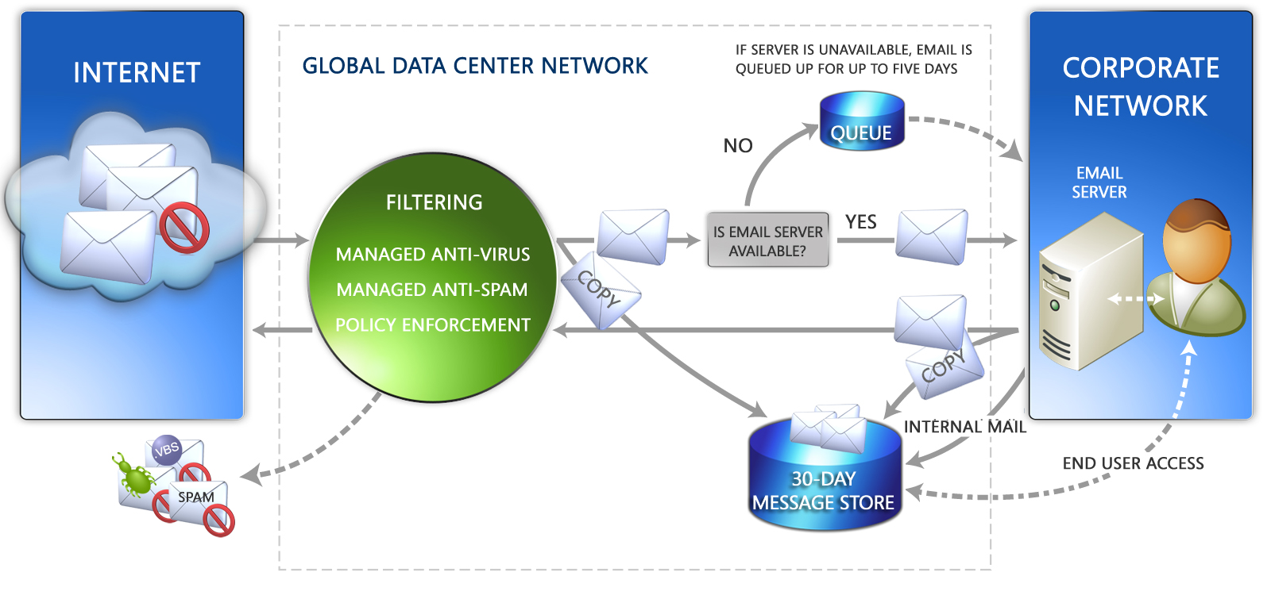  HOW IT WORKS  AMC intercepts and makes copies of inbound, outbound, and internal email and stores those message copies in a 30-day rolling message store. The message store can be accessed 24/7 by email administrators and end users to recover messages that may have been lost or deleted from an enterprise’s primary email environment.  AMC’s Web-based interface includes email tools for composing, reading, and replying to email, ensuring continual access to all email functionality even when the primary email environment is unavailable or a backup email system is needed. Any messages sent via the Web-based tools can be automatically merged into the primary mail system to complete disaster recovery operations.  Finally, if the primary mail environment is down or a business’ network is unavailable, preventing normal delivery of email, AMC continues to copy messages to the message store and queues the original message for delivery once the primary email environment is restored.  continued…
  BENEFITS
  • Always-on email continuity and disaster recovery service; no need to “flip a switch” to declare disaster mode.
  • Interception-based archiving captures messages in transit and works in concert with FrontBridge Message Security Services to ensure spam, viruses, and other unwanted content are kept out of the message store.
  • Easy-to-use Web-based tools require minimal training and allow access to the message store for end users from any location.
  • Continuous access to email and all email functionality, even when the primary email system is unavailable.
  • Searchable message store for easy recovery and restoration of individual and groups of messages.
  • Service delivery eliminates the need for capital investment and offloads maintenance and upgrades to FrontBridge, the messaging experts.
FRONTBRIDGE ACTIVE MESSAGE CONTINUITY
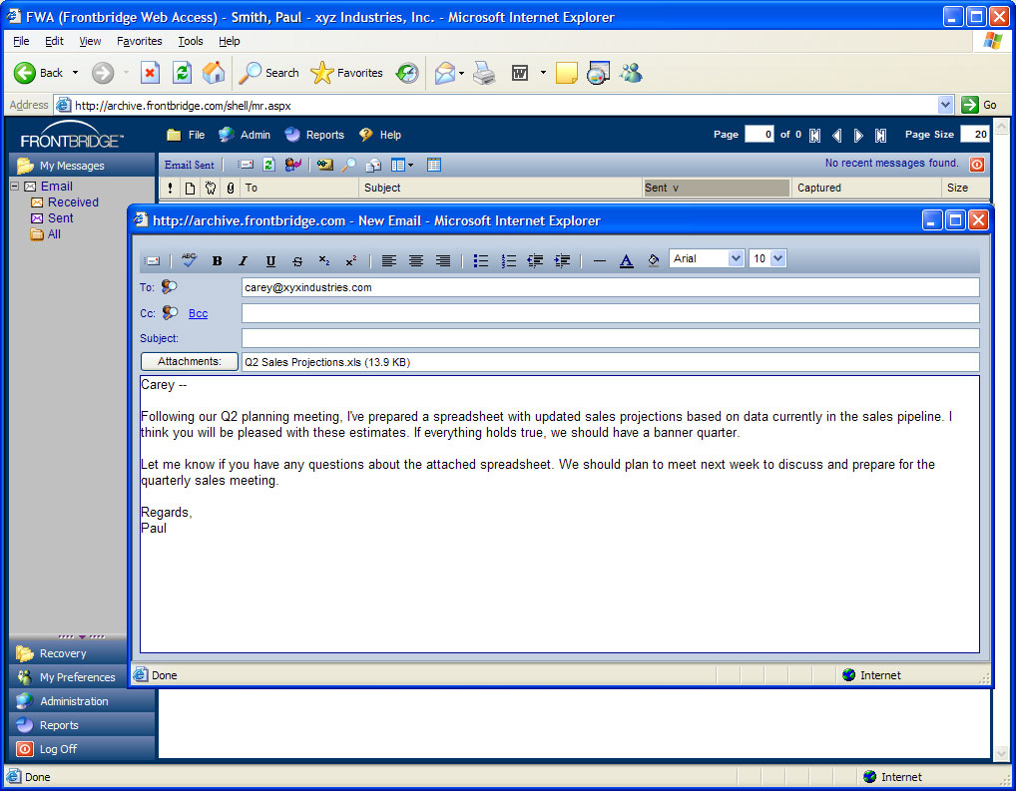
FrontBridge AMC provides critical business continuity support by giving enterprises continual access to email functionality.

FEATURES
• Email continuity and disaster recovery delivered as a managed service with 30-day message storage
• Interception-based archiving for inbound and outbound email; internal email captured via journaling from the primary email server
• Web-based access to message store and email tools for end users and administrators
• Web-based tools for composing, reading, forwarding, restoring, and replying to email
• Ability to configure roles and access privileges; global and individual settings
• Event log to track and report system activity
• Call tree lists for notifying staff in the event of an outage
• Message restoration after outage
• Global password reset for users in the event of an emergency
• Searchable message store; users can search message header; retrieve and restore searched messages
• Summary and drill down email traffic reports, delivered in Adobe Acrobat (PDF) format; reports can be scheduled and delivered via email
The information contained in this document represents the current view of Microsoft Corporation on the issues discussed as of the date of publication. This document is for informational purposes only. MICROSOFT MAKES NO WARRANTIES, EXPRESS OR IMPLIED, IN THIS DOCUMENT. © 2005 Microsoft Corporation. All rights reserved.

