
Global Investment Bank Builds Email Compliance Program on FrontBridge Email Archiving Technology
RSM EquiCo, Inc. is a global investment banking firm specializing in mergers and acquisitions, divestitures and corporate finance for private middle-market businesses. The firm is a wholly- owned subsidiary of H&R Block, Inc. Primarily serving companies with annual revenues of $3 million to $500 million, RSM EquiCo helps North American business owners operating in a broad range of industries evaluate, improve, grow and sell their companies.  Based in Costa Mesa, Calif., and with additional offices in Chicago, New York and London, RSM EquiCo employs more than 400 professionals and support staff.  BUSINESS CHALLENGE  In October 2003, RSM EquiCo had reached a critical juncture. Its officers had received notice that the National Association of Broker Dealers (NASD) would be arriving in early 2004 for an annual process and procedures audit. Email retention and monitoring was high on the list of items for review.  Chief Compliance Officer, John Dal Poggetto, had implemented a rudimentary system of archiving email based on some simple features within the Microsoft Outlook program but he knew his home-grown solution would not meet the NASD’s stringent requirements for supervising, monitoring, retaining and reporting on email.  “We realized quickly that we had to bring in an expert if we were going to pass the NASD’s audit requirements,” said Dal Poggetto. “Our in-house solution allowed us to retain email, but providing immediate access to email for supervision and monitoring was beyond our system’s capabilities. We needed a partner to come in and implement a system that required no time consuming or expensive capital outlay.”  EVALUATION PROCESS  The audit was approaching fast and Dal Pogetto had no time to waste in the lengthy process of evaluating solutions that require costly implementations. He immediately sought out a service-based message archiving system, since it didn’t require additional hardware or software to manage on-premise. The service-based approach would transfer the burden of application support to the service provider, rather than the company’s IT staff, resulting in lower costs and more efficient use of precious IT resources.  Dal Poggetto chose to take a closer look at FrontBridge’s message archiving solution. Initially, his management team had concerns over potential security issues of using a service provider, but they were immediately put at ease after viewing the company’s secure data center network.  “With the predictable monthly rate FrontBridge has provided us, there’s no way that our in-house solution could have offered us an even remotely similar application at our current cost,” said Dal Poggetto.  RSM EquiCo needed an email archiving solution that was flexible and provided a completely tamper-proof message store. It also had to include a supervisory system for regular review of incoming and outgoing messages based on statistical sampling. Finally, it needed the complete reporting functions required by the SEC and NASD. | 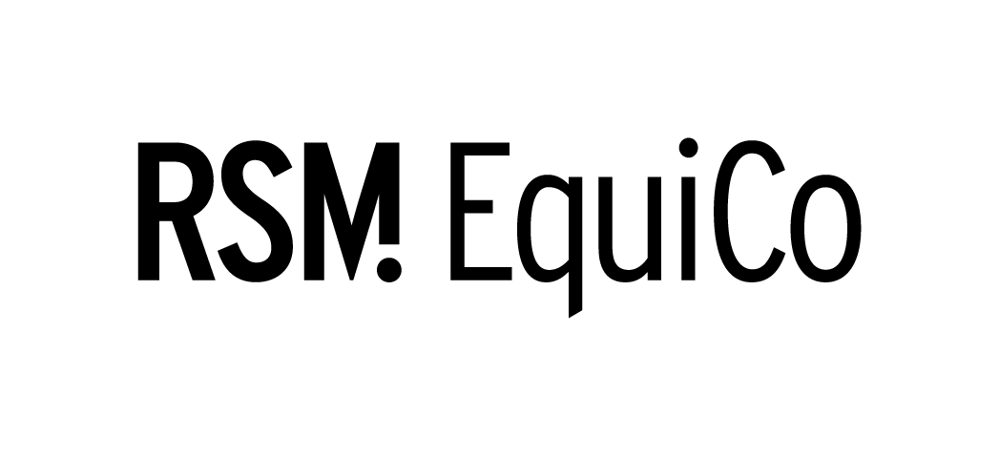
  THE BOTTOM LINE
  - Provided a comprehensive email archiving solution
  - Simplified RSM EquiCo’s NASD and SEC audit process
  - Decreased message management costs by thousands of dollars annually
“Rarely do you find a company that delivers a solution that does exactly what it claims. We put the email archiving solution through some rigorous testing and in all instances the service proved its merit,” said Dal Poggetto.  “The FrontBridge Message Archive service provided all the tools required for off-site message retention and recovery,” said Dal Poggetto. “FrontBridge offered a one-stop shop for all of RSM EquiCo’s message archival requirements.”  TWO AUDITS; THREE MONTHS  With the FrontBridge Message Archiving service up and running, Dal Poggetto was extremely confident that demonstrating email process and procedural compliance would be a less cumbersome task. In January 2004, the NASD scrutinized how the young company was storing, reviewing and supervising its company’s messaging.  With all his reports in order, Dal Poggetto was able to show an effective process for supervising and retaining messaging. What was expected to be an extensive and overwhelming process, in reality was a relatively short and organized exercise. Upon request, the auditor was presented with a set of usage reports outlining supervisory practices, sample messages, and alert systems. Dal Poggetto was able to leverage FrontBridge’s pre-defined NASD 3010 evidentiary reports to show that the broker/dealer communication with clients was in accordance with the stated rules. With FrontBridge in place, auditors were able to experience a painless process when sampling, flagging and reviewing messages based on key words.  “FrontBridge’s message archive service definitely made the audit process less painful. Auditors were confident that the messaging system met strict criteria and quickly moved onto other critical areas of the review,” said Dal Poggetto.  Within two months of passing its NASD audit, RSM EquiCo was audited again by the SEC with similar impressive results. The Securities and Exchange Commission made a surprise visit to audit the investment banking firm. Unexpectedly, the auditors arrived on site ready to conduct comprehensive systems audits. As a result of having the FrontBridge Message Archive System in place, RSM EquiCo was able to quickly produce supervision, retention and monitoring reports. One audit request was to provide the last 90 days of email from several targeted broker/dealers. Without FrontBridge’s automated system, the task would have required substantial hours restoring back up tapes and rebuilding servers to obtain needed information. Not only did FrontBridge streamline the auditing process, but it provided all the requested emails in one hour.  THE PERILS OF E-DISCOVERY  Unfortunately, litigation has become part and parcel of doing business in the United States. Increasingly, email has been called into evidence in several cases, ranging from sexual harassment allegations to employee misconduct. RSM EquiCo faced a situation requiring email to be produced as case evidence. Using the FrontBridge Message Archive service, the company was able to locate email requested by the courts in a simple fashion. Without the system in place, the organization would have had to assess allocations where email might exist by digging through backup tapes, file cabinets, desktop computers and offline media.  “FrontBridge Message Archive provides benefits beyond those required by regulatory agencies,” said Dal Poggetto. “We’ve used the tool to search and manage our email store, locating crucial messages required for legal purposes.”
  “Rarely do you find a company that delivers a solution that does exactly what it claims. We put the email archiving solution through some rigorous testing and in all instances the service proved its merit.”
  – John Dal Poggetto
  Chief Compliance Officer
COMPANY BENEFIT
With FrontBridge, RSM EquiCo was able to quickly implement a comprehensive email compliance service that helped them through the process in a less stressful manner. Messages aimed at RSM EquiCo’s 50 broker/dealers were intercepted and stored in a secure archive. Demonstrating compliance to auditors has become a painless process because of the systems set of pre-defined custom reports. The archive is also accessible by each employee, reducing the administrative burden of recovering past messages.
CONCLUSION
Since implementing FrontBridge’s managed services for message filtering and archiving, RSM EquiCo has armed itself and experienced the following:
• A comprehensive email archiving solution
• A simplified NASD and SEC audit process
• An annual expense-cut of thousands on message management costs
ABOUT FRONTBRIDGE TECHNOLOGIES
FrontBridge Technologies, a Microsoft Subsidiary, offers managed messaging services for enforcing compliance through archiving, ensuring e-mail availability in the case of a disaster, and improving protection of employee inboxes from viruses and spam. Its complete line of services includes message archiving, spam and virus filtering, disaster recovery, and email encryption and supports multiple e-mail platforms such as Microsoft® Exchange, IBM Lotus Domino, and other SMTP-compliant servers. These managed services provide value to corporate customers by requiring no upfront capital investment, minimizing IT management overhead, and removing incoming email threats before they reach the corporate firewall. FrontBridge is now part of Microsoft’s Exchange Server Group. For more information, visit www.microsoft.com/exchange
The information contained in this document represents the current view of Microsoft Corporation on the issues discussed as of the date of publication. This document is for informational purposes only. MICROSOFT MAKES NO WARRANTIES, EXPRESS OR IMPLIED, IN THIS DOCUMENT. © 2005 Microsoft Corporation. All rights reserved.

