
Louisville Slugger Knocks Spam Out of the Network with FrontBridge's Email Security Solution
Since 1884, Hillerich & Bradsby Co. Inc., has put prime lumber in the hands of the world's greatest baseball players. Its Louisville Slugger baseball bat has become the most famous product of its kind in the world. Used by more than 60 percent of all major league players, the Louisville Slugger bat has been crowned the "Official Bat of Major League Baseball."  Louisville Slugger continually looks for ways to make bats lighter and more efficient by using new materials and applying breakthrough sports technology. They apply that same philosophy to the company's productivity by utilizing the latest leading-edge technology to improve their email security system.  BUSINESS CHALLENGE  In 2002, Louisville Slugger was on the way to discontinuing the use of corporate email in favor of an email service. Email wasn't used company-wide and it was about to disappear completely. The reason? Spam. Thousands of unwanted emails were wreaking havoc on the company's network every day. Employees that used email were spending upwards of one hour each day sorting through spam and their junk mail folder. In addition, Louisville Slugger was hitting its critical threshold of 90 percent capacity with their Internet Service Provider at least four times per week.  "Once we realized the impact spam was having on our network and users' productivity, it became a choice between an email security solution and getting rid of corporate email altogether," said Gary Ward, LAN/WAN manager.  The Louisville Slugger IT department evaluated a variety of solutions from inexpensive to pricey, and found many were difficult to load, hard to configure and placed the responsibility to manage various lists on the users. Only FrontBridge made the cut as a cost-effective, easy-to-implement and comprehensive enterprise email security solution.  FRONTBRIDGE EMAIL SECURITY SOLUTION  Immediately after the Louisville Slugger's IT staffers experimented with FrontBridge's anti-spam solution, there was immediate concern - the amount of email coming through was so dramatically reduced that the IT staff thought their email server wasn't working properly. In fact, only good email was getting through.  As anti-spam technology thwarts spammers on a regular basis, they send more and more email in order to maintain their "hit rate." In addition, virus writers are getting in on the act, sending spam containing Trojan viruses that install backdoors on computers allowing for later access or install keystroke logging software, letting the sender steal sensitive personal or corporate information.  "75 percent of our email is spam," said Craig Burcham, LAN/WAN technician. "In a typical month, our company gets hit with 250,000 email messages and only 60,000 of those are good email messages. On top of that, we've significantly reduced the amount of email-borne viruses that we receive. In one month, FrontBridge stopped 7,000 viruses from having the chance to wreak havoc on our network." | 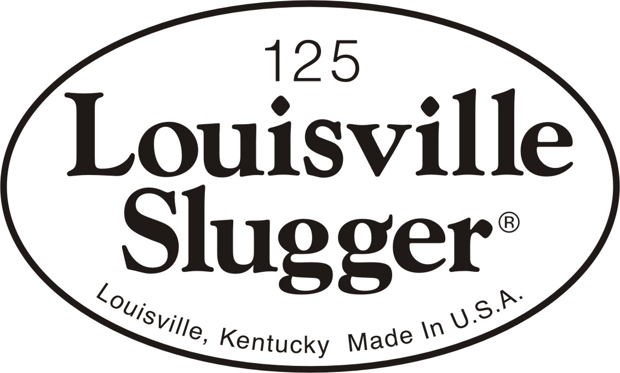
  THE BOTTOM LINE
  - Thousands of unwanted emails blocked every month
  - Thousands of spammed viruses blocked every month
  - Zero false positives
  - Eliminated costs of expanding network capacity to handle deluge of spam
  - Just a few hours to set up; immediate results
  - Completely maintenance-free
  - Boosted productivity; users are not required to manage lists
  - Email held when network is down via disaster recovery feature
Stealing Back Your Bandwidth  Since FrontBridge is a managed service that stops spam before it even enters the network, Louisville Slugger has seen a noticeable improvement in their bandwidth.  "Without the FrontBridge service, we would have had to increase our bandwidth through our ISP and add more hardware and software to manage the network traffic volume. The cost outlay weighed against the advantages of email would likely have led us to abandon corporate email altogether," said Ward.  Since deploying FrontBridge, the bandwidth alerts from their ISP have stopped, as they are no longer reaching the 90 percent capacity mark on a regular basis.  Maintaining a Low FPR (False Positive Rate)  Another upside of the FrontBridge service is the low false positive rate. "In the year that Louisville Slugger has used FrontBridge, we've only had one false positive - and it turned out to be a policy violation from one of our own employees," added Burcham.  With such a positive experience, Louisville Slugger no longer has to limit email to certain key employees; they were able to roll it out company-wide.  Disaster Recovery Feature Puts Email in the Bullpen  FrontBridge's managed service also has the ability to accept and hold email for its customers when their networks are down. Louisville Slugger calls this a "fringe benefit."  "In one instance, our firewall was not accepting outside email and we were unaware of the problem. Two hours later, FrontBridge sent us an alert that they were holding quite a bit of email for us - that's how we learned about the problem. Once we had the network back up, FrontBridge delivered all of our email without a hitch," said Burcham.  BENEFITS TO LOUISVILLE SLUGGER  Overall, FrontBridge's managed service approach helped Louisville Slugger not only keep its corporate email, but expand the user base, increase employee productivity and slash IT maintenance costs associated with the explosion of email traffic. FrontBridge's enterprise email security service has surpassed Louisville Slugger's expectations. "The FrontBridge service is fabulous, it's maintenance-free and I recommend it every chance I get," said Ward. "The bottom line is FrontBridge saved email for Louisville Slugger and left the IT department free to work on real business issues - that's a home run for our team."  THE END RESULT  Since implementing FrontBridge enterprise email security, Louisville Slugger has experienced the following benefits:  • Thousands of unwanted emails blocked every month  • Thousands of spammed viruses blocked every month  • Zero false positives  • Eliminated costs of expanding network capacity to handle deluge of spam  • Just a few hours to set up; immediate results  • Completely maintenance-free  • Boosted productivity; users are not required to manage lists  • Email held when network is down via disaster recovery feature
  “In a typical month, our company gets hit with 250,000 email messages and only 60,000 of those are good email messages. On top of that, we've significantly reduced the amount of email-borne viruses that we receive. In one month, FrontBridge stopped 7,000 viruses from having the chance to wreak havoc on our network.
  – Craig Burcham,
  LAN/WAN Technician
ABOUT FRONTBRIDGE TECHNOLOGIES  FrontBridge Technologies, a Microsoft subsidiary, offers managed messaging services for enforcing email compliance with encryption and archiving tools, providing email availability through a web-based back up, and improving protection of employee inboxes from viruses and spam. Its complete line of services includes message archiving, spam and virus filtering, disaster recovery, and email encryption and supports multiple e-mail platforms such as Microsoft® Exchange, IBM Lotus Domino, and other SMTP-compliant servers. These managed services provide value to corporate customers by requiring no upfront capital investment, minimizing IT management overhead, and removing incoming email threats before they reach the corporate firewall. FrontBridge is now part of Microsoft’s Exchange Server Group. For more information, visit http://www.microsoft.com/exchange
  "In one instance, our firewall was not accepting outside email and we were unaware of the problem. Two hours later, FrontBridge sent us an alert that they were holding quite a bit of email for us - that's how we learned about the problem. Once we had the network back up, FrontBridge delivered all of our email without a hitch,"
  – Craig Burcham,
  LAN/WAN Technician
The information contained in this document represents the current view of Microsoft Corporation on the issues discussed as of the date of publication. This document is for informational purposes only. MICROSOFT MAKES NO WARRANTIES, EXPRESS OR IMPLIED, IN THIS DOCUMENT. © 2005 Microsoft Corporation. All rights reserved.

